

**CAPSTONE PROJECT REPORT**

**Report 3 – Software Requirement Specification**

– Hanoi, Octorber 2023 –

**Table of Contents**

I. Record of Changes 4

II. Software Requirement Specification 5

1. Product Overview 5

2. User Requirements 5

2.1 Actors 5

2.2 Use Cases 6

2.2.1 Diagram(s) 6

2.2.2 Use case Descriptions 8

2.2.2.1 Login 11

2.2.2.2 Log out 12

2.2.2.3 Add new user 13

2.2.2.4 View user list 14

2.2.2.5 Edit user information 15

2.2.2.6 Disable user 15

2.2.2.7 Add department 16

2.2.2.8 View View department list 17

2.2.2.9 Edit department name 18

2.2.2.10 Disable department 18

2.2.2.11 Add new service type 19

2.2.2.12 Add new service 20

2.2.2.13 View service type list 21

2.2.2.14 View Service Detail 21

2.2.2.15 Edit Service type 22

2.2.2.16 Disable service type 23

2.2.2.17 View service list 23

2.2.2.18 Edit service 24

2.2.2.19 Disable service 25

2.2.2.20 Add new medicine type 26

2.2.2.21 View medicine type list 26

2.2.2.22 Edit medicine type 27

2.2.2.23 Disabe medicine type 28

2.2.2.24 View medicine list 28

2.2.2.25 Edit medicine 29

2.2.2.26 Disable medicine 30

2.2.2.27 View medical record list 31

2.2.2.28 View medical record detail 31

2.2.2.29 View prescription 32

2.2.2.30 Add new patient 33

2.2.2.31 View patient list 33

2.2.2.32 Create Medical record 34

2.2.2.33 Appoint doctor 35

2.2.2.34 View Examination Result 36

2.2.2.35 Export medical record to pdf file 36

2.2.2.36 View a patient’s medical record list 37

2.2.2.37 View unpaid medical record list 38

2.2.2.38 View paid medical record list 38

2.2.2.39 View invoice 39

2.2.2.40 Export invoice to pdf file 40

2.2.2.41 Confirm a medical record has been paid 41

2.2.2.42 View list of examined medical records 41

2.2.2.43 View list of unexamined medical records 42

2.2.2.44 Create prescription 43

2.2.2.45 Export description to pdf file 43

2.2.2.46 Add medical examination result 44

3. Functional Requirements 45

3.1 System Functional Overview 45

3.1.1 Screens Flow 45

3.1.2 Screen Descriptions 45

3.1.3 Screen Authorization 47

3.1.4 Entity Relationship Diagram 48

3. Non-Functional Requirements 49

3.1 External Interfaces 49

3.1.1 Push-up notification Integration: 49

3.1.2 Integration with Monitoring and Alerting Tools: 49

3.2 Quality Attributes 49

3.2.1 Security: 49

3.2.2 Usability: 50

4. Requirement Appendix 50

4.1 Business Rules 50

4.2 Application Messages List 51

# I. Record of Changes

| **Date** | **A* M, D** | **In charge** | **Change Description** |
| --- | --- | --- | --- |
| 15/10/2023 | A | Report Create | Create the report item 1 |
| 13/11/2023 | A | Add | Add item 2 |
| 16/12/2023 | M | Modify | Modify report |
|  |  |  |  |
|  |  |  |  |
|  |  |  |  |
|  |  |  |  |
|  |  |  |  |
|  |  |  |  |
|  |  |  |  |
|  |  |  |  |
|  |  |  |  |
|  |  |  |  |

*A - Added M - Modified D - Deleted

# II. Software Requirement Specification

## 1. Product Overview

We are developing a comprehensive clinic management solution specifically tailored for small outpatient healthcare facilities in the medical industry. The software's primary goal is to streamline and optimize clinic operations, offering a suite of features that simplify patient management, financial transactions, and pharmacy services. While the software doesn't directly interact with patients, it is meticulously designed to cater to the unique needs of medical professionals, administrators, and support staff in these clinical settings. Key features of this solution encompass efficient patient record management, pharmacy service management capabilities, user authentication and access control measures, a user-friendly interface for intuitive navigation, and analysis functions. This software is a valuable asset for small outpatient clinics, enhancing their operational efficiency and helping them provide quality care to their patients.

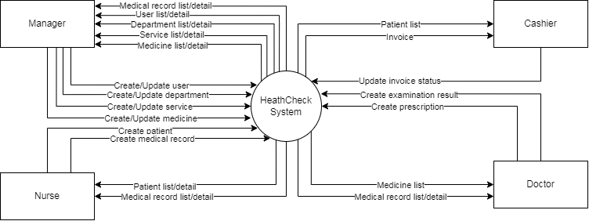

**Figure 1: HealthCheck System Context Diagram**

## 2. User Requirements

### 2.1 Actors

Table [Table 1](https://docs.google.com/document/d/1X0LYhDp8U3h7i5xrAtJQ1yWt_zpK1mPq/edit#heading=h.2et92p0) describe a list of actors that interact with HealthCheck System, it includes Manager, Nurse, Cashier, Doctor

**Table 1: HealthCheck System Actor List**

| **#** | **Actor** | **Description** |
| --- | --- | --- |
| 1 | Manager | Responsible for managing users and accessing invoice information, revenue statistics |
| 2 | Nurse | Responsible for inquiring about the patient's condition and creating patient medical records. |
| 3 | Cashier | Responsible for generating invoices for provided services. |
| 4 | Doctor | Responsible for reviewing patient medical records, creating examination results, and prescribing medication after the examination |

### 2.2 Use Cases

#### 2.2.1 Diagram(s)



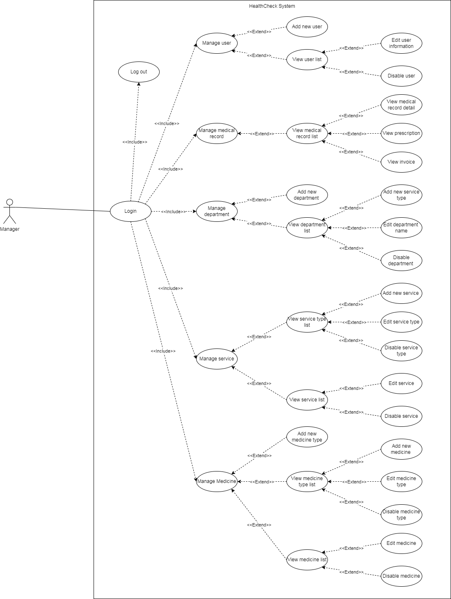

**Figure 2: Use Case Diagram - Manager Use Case**

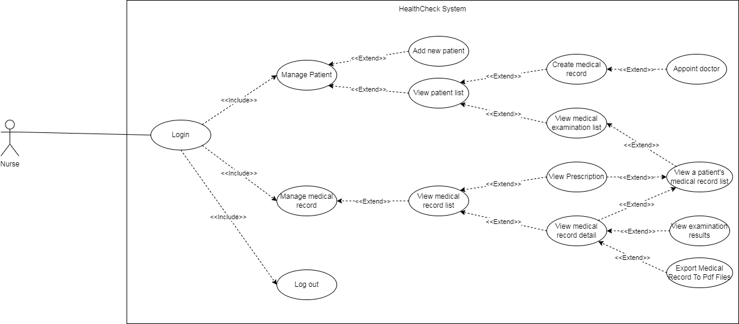

**Figure 3: Use Case Diagram - Nurse Use Case**

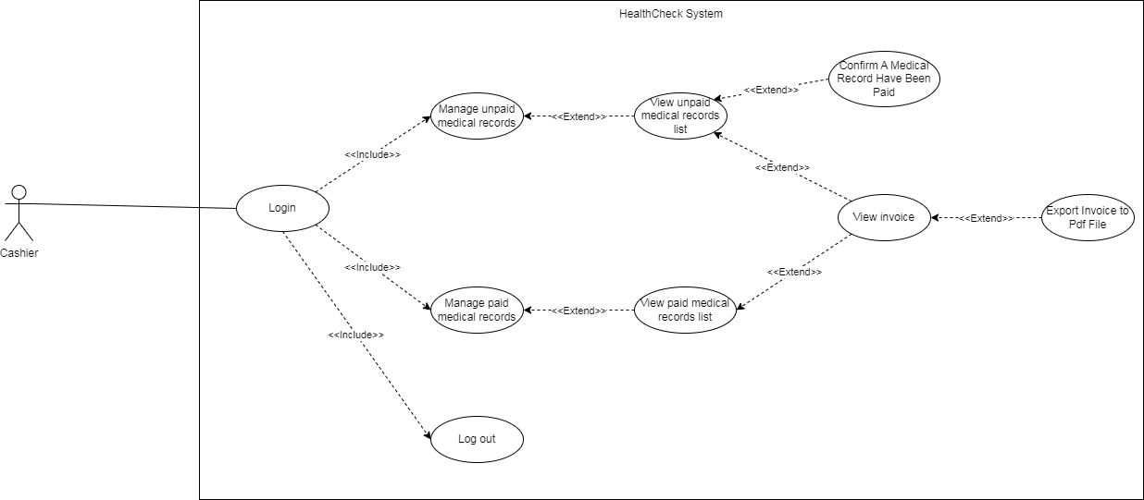

**Figure 4: Use Case Diagram - Cashier Use Case**

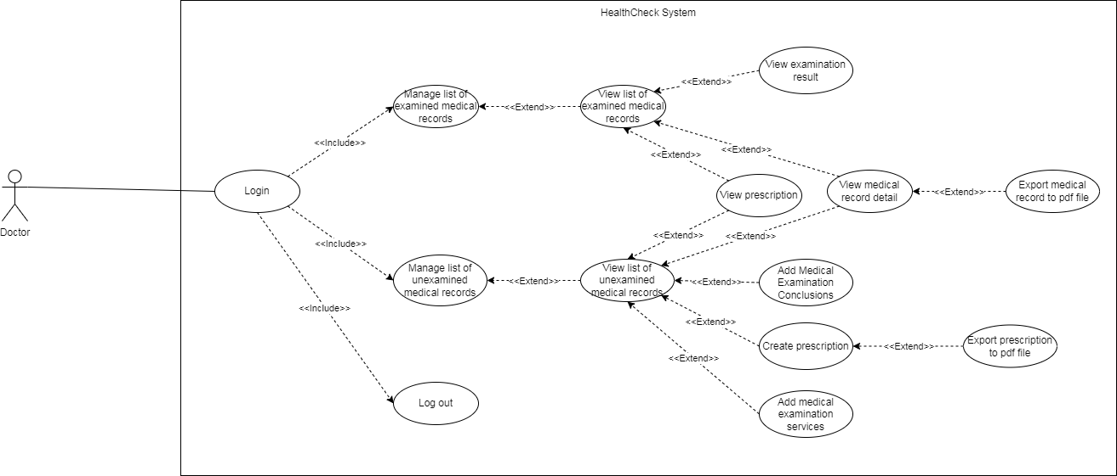

**Figure 4: Use Case Diagram - Doctor Use Case**

#### 2.2.2 Use case Descriptions

| **ID** | **Use Case** | **Actors** | **Use Case Description** |
| --- | --- | --- | --- |
| UC-01 | Login | Manager, Doctor, Nurse, Cashier | This use case outlines the steps and interactions involved in the authentication process for users (Administrator, Doctor, Nurse, Cashier) to gain access to the HCS system. The purpose is to ensure secure access and grant authorization to system features. |
| UC-02 | Log out | Manager, Doctor, Nurse, Cashier | This use case describes the process and interactions when a user (Administrator, Doctor, Nurse, Cashier) initiates logout in the HCS system. It terminates the user's session and redirects to the login page. |
| UC-03 | Add new user | Manage | This use case allows the Manager to create and add a new user account with a role to the HCS system. It involves entering user details and assigning a role. |
| UC-04 | View user list | Manage | This use case allows the Manager to view a list of all existing user accounts in the HCS system. |
| UC-05 | Edit user information | Manage | This use case allows the Manager to edit the profile information of an existing user account in the HCS system. |
| UC-06 | Disable user | Manage | This use case allows the Manager to disable or deactivate a user account in the HCS system. The disabled user cannot log in. |
| UC-07 | Add department | Manage | This use case allows the Manager to create and add a new department in the HCS system. It involves entering department details. |
| UC-08 | View department list | Manage | This use case allows the Manager to view a list of all existing departments in the HCS system. |
| UC-09 | Edit department name | Manage | This use case allows the Manager to edit the name of an existing department in the HCS system. |
| UC-10 | Disable department | Manage | This use case allows the Manager to disable or deactivate a department in the HCS system. |
| UC-11 | Add new service type | Manager | This use case allows the Manager to create and add a new service type in the HCS system. It involves entering service type details. |
| UC-12 | Add new service | Manager | This use case allows the Manager to create and add a new service in the HCS system. It involves entering service details. |
| UC-13 | View service type list | Manager | This use case allows the Manager to view a list of all existing service types in the HCS system. |
| UC-14 | View Service Detail | Manager | This use case allows the Manager to view the details of a specific service in the HCS system. |
| UC-15 | Edit service type | Manager | This use case allows the Manager to edit the details of an existing service type in the HCS system. |
| UC-16 | Disable service type | Manager | This use case allows the Manager to disable or deactivate a service type in the HCS system. |
| UC-17 | View service list | Manager | This use case allows the Manager to view a list of all existing services in the HCS system. |
| UC-18 | Edit service | Manager | This use case allows the Manager to edit the details of an existing service in the HCS system |
| UC-19 | Disable service | Manager | This use case allows the Manager to disable or deactivate a service in the HCS system. |
| UC-20 | Add new medicine type | Manager | This use case allows the Manager to create and add a new medicine type in the HCS system. It involves entering medicine type details. |
| UC-21 | View medicine type list | Manager | This use case allows the Manager to view a list of all existing medicine types in the HCS system. |
| UC-22 | Edit medicine type | Manager | This use case allows the Manager to edit the details of an existing medicine type in the HCS system. |
| UC-23 | Disabe medicine type | Manager | This use case allows the Manager to disable or deactivate a medicine type in the HCS system. |
| UC-24 | View medicine list | Manager | This use case allows the Manager to view a list of all existing medicines in the HCS system. |
| UC-25 | Edit medicine | Manager | This use case allows the Manager to edit the details of an existing medicine in the HCS system. |
| UC-26 | Disable medicine | Manager | This use case allows the Manager to disable or deactivate a medicine in the HCS system. |
| UC-27 | View medical record list | Manager | This use case allows the Manager, Doctor and Nurse to view a list of all medical records in the HCS system. |
| UC-28 | View medical record detail | Manager, Doctor, Nurse, Cashier | This use case allows the Manager, Doctor and Nurse to view the details of a specific medical record in the HCS system. |
| UC-29 | View prescription | Manager, Doctor, Nurse | This use case allows the Manager, Doctor and Nurse to view the prescription information for a medical record in the HCS system. |
| UC-30 | Add new patient | Nurse | This use case allows the Nurse to create and add a new patient profile in the HCS system. It involves entering patient details. |
| UC-31 | View patient list | Nurse | This use case allows the Nurse to view a list of all patients in the HCS system. |
| UC-32 | Create Medical record | Nurse | This use case allows the Nurse to create a medical record for a patient in the HCS system. |
| UC-33 | Appoint doctor | Nurse | This use case allows the Nurse to appoint a doctor for a patient's medical record in the HCS system. |
| UC-34 | View Examination Result | Manager, Doctor, Nurse | This use case describes displaying the patient's examined medical examination results according to the corresponding examination services |
| UC-35 | Export medical record to pdf file | Manager, Doctor, Nurse | This use case allows the Manager, Doctor and Nurse to export a medical record to a PDF file |
| UC-36 | View a patient’s medical record list | Nurse | This use case allows the Nurse to view a list of all medical records belonging to a patient in the HCS system. |
| UC-37 | View unpaid medical record list | Cashier | This use case allows the Cashier to view a list of unpaid medical records in the HCS system. |
| UC-38 | View paid medical record list | Cashier | This use case allows the Cashier to view a list of paid medical records in the HCS system. |
| UC-39 | View invoice | Cashier, Manager | This use case allows the Cashier to view a list of paid medical records in the HCS system. |
| UC-40 | Export invoice to pdf file | Cashier | This use case allows the Cashier to export a medical record invoice to PDF format in the HCS system. |
| UC-41 | Confirm a medical record has been paid | Cashier | This use case allows the Cashier to confirm in the system that a medical record invoice has been paid. |
| UC-42 | View list of examined medical records | Doctor | This use case allows the Doctor to view a list of medical records that have been examined for a patient. |
| UC-43 | View list of unexamined medical records | Doctor | This use case allows the Doctor to view a list of medical records that are pending examination for a patient. |
| UC-44 | Create prescription | Doctor | This use case allows the Doctor to create a prescription for a medical record in the HCS system. |
| UC-45 | Export description to pdf file | Doctor | This use case allows the Doctor to export a created prescription to PDF format in the HCS system. |
| UC-46 | Add medical examination result | Manager, Doctor, Nurse | This use case allows the Doctor to add examination findings and results for a medical record in the HCS system. |

##### 2.2.2.1 Login

**Table 2: Use Case Login**

| ID: | UC-01 | | |
| --- | --- | --- | --- |
| Name: | Login | | |
| Created by: | KienBT | Date created: | 15/10/2023 |
| Primary actor: | Administrator, Doctor, Nurse, Cashier | Secondary actor: | None |
| Description: | This use case outlines the steps and interactions involved in the authentication process for users to gain access to the HCS system. The purpose of this use case is to ensure secure access to the system and grant authorized. | | |
| Trigger: | 1. User accesses the login page. 2. When the user wants to access a system feature without authentication. 3. When the user's access token expires, it will switch back to login. | | |
| Pre-condition: | 1. The HCS system is operational and accessible. 2. The user has valid login credentials (email and password). | | |
| Post-condition: | 1. After successful login, the user can access the features corresponding to the account just logged in. 2. In case of login failure, the system will give appropriate feedback for the user to log in again. | | |
| Normal flow: | 1. Navigate to the login page. 2. The login form is displayed and the user enters the email and password. 3. The system will check the login information with the saved data. 4. Valid credentials, the system will go to the feature the user wants to access or the Home page. | | |
| Alternative flows | *None* | | |
| Exceptions: | 1. User enter wrong email or password 2. The system displays an error message and asks the user to re-enter | | |
| Priority: | High | | |
| Frequency of use: | High | | |
| Businesses rules: |  | | |
| Assumption: | None | | |
| Other informations: | None | | |

##### 2.2.2.2 Log out

**Table 3: Use Case Log Out**

| ID: | UC-02 | | |
| --- | --- | --- | --- |
| Name: | Log out | | |
| Created by: | KienBT | Date created: | 15/10/2023 |
| Primary actor: | Administrator, Doctor, Nurse, Cashier | Secondary actor: | None |
| Description: | This use case describes the process and associated interactions when a user initiates the logout action in an HCS system. | | |
| Trigger: | 1. When user clicks button “Log Out” | | |
| Pre-condition: | 1. The user is currently logged in to the system | | |
| Post-condition: | 1. The current session will be deleted and redirected to the login page | | |
| Normal flow: | 1. The User clicks button “Log out” in nav bar 2. The system terminates the user’s session. 3. Redirect to Login Page | | |
| Alternative flows: | None | | |
| Exceptions: | None | | |
| Priority: | Medium | | |
| Frequency of use: | Medium | | |
| Businesses rules |  | | |
| Assumption: | None | | |
| Other informations | None | | |

##### 2.2.2.3 Add new user

**Table 4: Use Case Add new user**

| ID: | UC-03 | | |
| --- | --- | --- | --- |
| Name: | Add new user | | |
| Created by: | KienBT | Date created: | 15/10/2023 |
| Primary actor: | Manager | Secondary actor: | None |
| Description: | Manager can create a new user in the system by fill user information and new account into system. | | |
| Trigger: | Manager initiates user creation. | | |
| Pre-condition: | 1. Manager is logged in.  2. Manager has permission to add user. | | |
| Post-condition: | New user account created in system. | | |
| Normal flow: | 1. Manager clicks on "Add New User" button  2. System redirects Manager to the Add User page  3. Manager fills in details like name, email, role, etc. in the form  4. Manager clicks on "Submit" button to add the new user  5. System validates the input details. If details are valid, system adds the new user and displays confirmation message | | |
| Alternative flows: | None | | |
| Exceptions: | 1. Invalid details entered.  2. System error prevents member creation. | | |
| Priority: | Medium | | |
| Frequency of use: | Low | | |
| Businesses rules: | None | | |
| Assumption: | None | | |
| Other informations | None | | |

##### 2.2.2.4 View user list

**Table 5: Use Case View user list**

| ID: | UC-04 | | |
| --- | --- | --- | --- |
| Name: | View user list | | |
| Created by: | KienBT | Date created: | 17/10/2023 |
| Primary actor: | Manager | Secondary actor: | None |
| Description: | This use case allows the Manager to view a list of all existing useraccounts in the HCSsystem. | | |
| Trigger: | User accounts exist user list | | |
| Pre-condition: | 1. Manager is logged in.  2. User accounts exist in system | | |
| Post-condition: | User list displayed to Manager | | |
| Normal flow: | 1. Manager clicks on "View Users" option  2. System retrieves list of all users from the database  3. System displays the user list with details like name, email, role etc. in a tabular format  4. Manager can search, sort and paginate the user list | | |
| Alternative flows: | None | | |
| Exceptions: | None | | |
| Priority: | Medium | | |
| Frequency of use: | None | | |
| Businesses rules: | None | | |
| Assumption: | None | | |
| Other informations | None | | |

##### 2.2.2.5 Edit user information

**Table 6: Use Case Edit user information**

| ID: | UC-05 | | |
| --- | --- | --- | --- |
| Name: | Edit user information | | |
| Created by: | KienBT | Date created: | 20/10/2023 |
| Primary actor: | Manager | Secondary actor: | None |
| Description: | This use case describes the information of an account in the system and the manager can edit the information or decide whether this account is still active in the system or not. | | |
| Trigger: | Manager selects to edit user details. | | |
| Pre-condition: | 1. Manager is logged in.  2. Selected user exists. | | |
| Post-condition: | User details updated in system. | | |
| Normal flow: | 1. Manager selects a user from the user list  2. System enables edit mode for that user's details  3. Manager modifies details like name, email, role etc.  4. Manager clicks "Update" button to save changes  5. System validates the updated details. If details are valid, system updates user details in database | | |
| Alternative flows: | None | | |
| Exceptions: | 1. Invalid data input.  2. System error during update. | | |
| Priority: | Medium | | |
| Frequency of use: | Low | | |
| Businesses rules: | None | | |
| Assumption: | None | | |
| Other informations | None | | |

##### 2.2.2.6 Disable user

**Table 7: Use Case Disable user**

| ID: | UC-06 | | |
| --- | --- | --- | --- |
| Name: | Disable user | | |
| Created by: | KienBT | Date created: | 21/10/2023 |
| Primary actor: | Manager | Secondary actor: | None |
| Description: | This use case allows the Manager to disable or deactivate a user account in the HCS system. The disabled user cannot log in. | | |
| Trigger: | Manager selects to disable a user account. | | |
| Pre-condition: | 1. Manager is logged in.  2. Selected user account exists. | | |
| Post-condition: | User account disabled in system. | | |
| Normal flow: | 1. Manager selects a user from user list to disable  2. System prompts for disable confirmation  3. Manager confirms disabling of user  4. System updates user status as disabled in database  5. Disabled user can no longer log into system | | |
| Alternative flows: | None | | |
| Exceptions: | None | | |
| Priority: | Medium | | |
| Frequency of use: | Low | | |
| Businesses rules: | None | | |
| Assumption: | None | | |
| Other informations | None | | |

##### 2.2.2.7 Add department

**Table 8: Use Case Add department**

| ID: | UC-07 | | |
| --- | --- | --- | --- |
| Name: | Add department | | |
| Created by: | KienBT | Date created: | 25/10/2023 |
| Primary actor: | Manager | Secondary actor: | None |
| Description: | This use case allows the Manager to create and add a new department in the HCS system. It involves entering department details. | | |
| Trigger: | Manager initiates adding a new department. | | |
| Pre-condition: | 1. Manager is logged in. | | |
| Post-condition: | New department added in system. | | |
| Normal flow: | 1. Manager clicks on "Add Department" option  2. Add Department form is displayed  3. Manager fills department details like name, description  4. Manager clicks on "Add" button  5. System validates the department details. If valid, new department is added to database | | |
| Alternative flows: | None | | |
| Exceptions: | 1. Invalid details entered.  2. System display error message | | |
| Priority: | Medium | | |
| Frequency of use: | Low | | |
| Businesses rules: | BR-04 | | |
| Assumption: | None | | |
| Other informations | None | | |

##### 2.2.2.8 View View department list

**Table 9: Use Case View department list**

| ID: | UC-08 | | |
| --- | --- | --- | --- |
| Name: | View department list | | |
| Created by: | KienBT | Date created: | 30/10/2023 |
| Primary actor: | Manager | Secondary actor: | None |
| Description: | This use case allows the Manager to view a list of all existing departments in the HCS system. | | |
| Trigger: | Manager selects to view department list | | |
| Pre-condition: | 1. Manager is logged in.  2. Departments exist in system. | | |
| Post-condition: | Department list displayed to Manager. | | |
| Normal flow: | 1. Manager clicks on "View Departments" option  2. System retrieves list of all departments  3. List of departments is displayed with details like name, description  4. Manager can search and filter the departments list | | |
| Alternative flows: | None | | |
| Exceptions: | None | | |
| Priority: | Medium | | |
| Frequency of use: | None | | |
| Businesses rules: | None | | |
| Assumption: | None | | |
| Other informations | None | | |

##### 2.2.2.9 Edit department name

**Table 10: Use Case Edit department name**

| ID: | UC-09 | | |
| --- | --- | --- | --- |
| Name: | Edit department | | |
| Created by: | KienBT | Date created: | 2/11/2023 |
| Primary actor: | Manager | Secondary actor: | None |
| Description: | This use case allows the Manager to edit the name of an existing department in the HCS system. | | |
| Trigger: | Manager selects to edit department name. | | |
| Pre-condition: | 1. Manager is logged in.  2. Selected department exists. | | |
| Post-condition: | Department name updated in system. | | |
| Normal flow: | 1. Manager selects a department from department list  2. Department details become editable  3. Manager updates department name  4. Manager clicks on "Update" button  5. System validates updated name. If valid, department name is updated in database | | |
| Alternative flows: | None | | |
| Exceptions: | 1. Invalid data input.  2. System error during update. | | |
| Priority: | Medium | | |
| Frequency of use: | Low | | |
| Businesses rules: | BR-04 | | |
| Assumption: | None | | |
| Other informations | None | | |

##### 2.2.2.10 Disable department

**Table 11: Use Case Disable department**

| ID: | UC-10 | | |
| --- | --- | --- | --- |
| Name: | Disable department | | |
| Created by: | KienBT | Date created: | 5/11/2023 |
| Primary actor: | Manager | Secondary actor: | None |
| Description: | Description: This use case allows the Manager to disable or deactivate a department in the HCS system. | | |
| Trigger: | Manager selects to disable a department. | | |
| Pre-condition: | 1. Manager is logged in.  2. Selected department exists. | | |
| Post-condition: | Department disabled in system. | | |
| Normal flow: | 1. Manager selects a department to disable  2. Confirmation is sought for disabling department  3. Manager confirms disabling of department  4. System updates department status as disabled  5. Disabled department is no longer available for use | | |
| Alternative flows: | None | | |
| Exceptions: | None | | |
| Priority: | Medium | | |
| Frequency of use: | Low | | |
| Businesses rules: | BR-06 | | |
| Assumption: | None | | |
| Other informations | None | | |

##### 2.2.2.11 Add new service type

**Table 12: Use Case Add new service type**

| ID: | UC-11 | | |
| --- | --- | --- | --- |
| Name: | Add new service type | | |
| Created by: | KienBT | Date created: | 9/11/2023 |
| Primary actor: | Manager | Secondary actor: | None |
| Description: | This use case allows the Manager to create and add a new service type in the HCS system. It involves entering service type details. | | |
| Trigger: | Manager initiates adding a new service type | | |
| Pre-condition: | 1. Manager is logged in | | |
| Post-condition: | New service type added in system | | |
| Normal flow: | 1. Manager clicks on "Add Service Type" option  2. Add Service Type form opens  3. Manager enters details like name, description for new service type  4. Manager clicks on "Add" button  5. System validates the service type details. If valid, new service type is added to database | | |
| Alternative flows: | None | | |
| Exceptions: | 1. Invalid details  2. System error | | |
| Priority: | Medium | | |
| Frequency of use: | Low | | |
| Businesses rules: | BR-08 | | |
| Assumption: | None | | |
| Other informations | None | | |

##### 2.2.2.12 Add new service

**Table 13: Use Case Add new service**

| ID: | UC-12 | | |
| --- | --- | --- | --- |
| Name: | Add new service | | |
| Created by: | KienBT | Date created: | 14/11/2023 |
| Primary actor: | Manager | Secondary actor: | None |
| Description: | This use case allows the Manager to create and add a new service in the HCS system. It involves entering service details. | | |
| Trigger: | Manager initiates adding a new service | | |
| Pre-condition: | 1. Manager is logged in.  2. Relevant service type exists. | | |
| Post-condition: | New service added in system | | |
| Normal flow: | 1. Manager clicks on "Add Service" option  2. Add Service form opens  3. Manager selects a service type for the new service  4. Manager enters details like name, description, price for new service  5. Manager clicks on "Add" button  6. System validates the service details. If valid, new service is added to database | | |
| Alternative flows: | None | | |
| Exceptions: | 1. Invalid details  2. System error | | |
| Priority: | Medium | | |
| Frequency of use: | Low | | |
| Businesses rules: | BR-08, BR-09, BR-21 | | |
| Assumption: | None | | |
| Other informations | None | | |

##### 2.2.2.13 View service type list

**Table 14: Use Case View service type list**

| ID: | UC-13 | | |
| --- | --- | --- | --- |
| Name: | View service type list | | |
| Created by: | KienBT | Date created: | 15/11/2023 |
| Primary actor: | Manager | Secondary actor: | None |
| Description: | This use case allows the Manager to view a list of all existing service types in the HCS system. | | |
| Trigger: | Manager selects to view service type list | | |
| Pre-condition: | 1. Manager is logged in.  2. Service types exist in system. | | |
| Post-condition: | Service type list displayed to Manager. | | |
| Normal flow: | 1. Manager clicks on "View Service Types" option  2. System retrieves list of all service types  3. List of service types displayed with details like name, description  4. Manager can search and filter the service types list | | |
| Alternative flows: | None | | |
| Exceptions: | None | | |
| Priority: | Medium | | |
| Frequency of use: | Medium | | |
| Businesses rules: | None | | |
| Assumption: | None | | |
| Other informations | None | | |

##### 2.2.2.14 View Service Detail

**Table 15: Use Case View Service Detail**

| ID: | UC-14 | | |
| --- | --- | --- | --- |
| Name: | View Service Detail | | |
| Created by: | KienBT | Date created: | 17/11/2023 |
| Primary actor: | Manager | Secondary actor: | None |
| Description: | This use case allows the Manager to view the details of a specific service in the HCS system. | | |
| Trigger: | Manager selects to view service details | | |
| Pre-condition: | 1. Manager is logged in.  2. Selected service exists. | | |
| Post-condition: | Service details displayed to Manager. | | |
| Normal flow: | 1. Manager selects a service from service list  2. System displays the details for that service like name, type, price etc.  3. Manager can view and verify the service details | | |
| Alternative flows: | None | | |
| Exceptions: | None | | |
| Priority: | Medium | | |
| Frequency of use: | Low | | |
| Businesses rules: | None | | |
| Assumption: | None | | |
| Other informations | None | | |

##### 2.2.2.15 Edit Service type

**Table 16: Use Case Edit service type**

| ID: | UC-15 | | |
| --- | --- | --- | --- |
| Name: | Edit Service type | | |
| Created by: | KienBT | Date created: | 20/11/2023 |
| Primary actor: | Manager | Secondary actor: | None |
| Description: | This use case allows the Manager to edit the details of an existing service type in the HCS system. | | |
| Trigger: | Manager selects to edit service type | | |
| Pre-condition: | 1. Manager is logged in.  2. Selected service type exists. | | |
| Post-condition: | Service type details updated in system. | | |
| Normal flow: | 1. Manager selects a service type to edit  2. Service type details become editable  3. Manager updates details like name, description  4. Manager clicks on "Update" button  5. System validates updated service type details. If valid, details are updated in database | | |
| Alternative flows: | None | | |
| Exceptions: | 1. Invalid data input  2. System error during update | | |
| Priority: | Medium | | |
| Frequency of use: | Low | | |
| Businesses rules: | None | | |
| Assumption: | None | | |
| Other informations | None | | |

##### 2.2.2.16 Disable service type

**Table 17: Use Case Disable service type**

| ID: | UC-16 | | |
| --- | --- | --- | --- |
| Name: | Disable service type | | |
| Created by: | KienBT | Date created: | 23/11/2023 |
| Primary actor: | Manager | Secondary actor: | None |
| Description: | This use case allows the Manager to disable or deactivate a service type in the HCS system. | | |
| Trigger: | Manager selects to disable a service type | | |
| Pre-condition: | 1. Manager is logged in.  2. Selected service type exists. | | |
| Post-condition: | Service type disabled in system. | | |
| Normal flow: | 1. Manager selects a service type to disable  2. Confirmation sought to disable service type  3. Manager confirms disabling  4. System updates status of service type as disabled  5. Disabled service type no longer available for use | | |
| Alternative flows: | None | | |
| Exceptions: | None | | |
| Priority: | Medium | | |
| Frequency of use: | Low | | |
| Businesses rules: | BR-10 | | |
| Assumption: | None | | |
| Other informations | None | | |

##### 2.2.2.17 View service list

**Table 18: Use Case View service list**

| ID: | UC-17 | | |
| --- | --- | --- | --- |
| Name: | View service list | | |
| Created by: | KienBT | Date created: | 25/11/2023 |
| Primary actor: | Manager | Secondary actor: | None |
| Description: | This use case allows the Manager to view a list of all existing services in the HCS system. | | |
| Trigger: | Manager selects to view service list | | |
| Pre-condition: | 1. Manager is logged in.  2. Services exist in system. | | |
| Post-condition: | Service list displayed to Manager | | |
| Normal flow: | 1. Manager clicks on "View Services" option  2. System retrieves list of all services  3. List of services displayed with details like name, type, price  4. Manager can search and filter services list | | |
| Alternative flows: | None | | |
| Exceptions: | None | | |
| Priority: | Medium | | |
| Frequency of use: | Medium | | |
| Businesses rules: | None | | |
| Assumption: | None | | |
| Other informations | None | | |

##### 2.2.2.18 Edit service

**Table 19: Use Case Edit service**

| ID: | UC-18 | | |
| --- | --- | --- | --- |
| Name: | Edit service | | |
| Created by: | KienBT | Date created: | 26/11/2023 |
| Primary actor: | Manager | Secondary actor: | None |
| Description: | This use case allows the Manager to edit the details of an existing service in the HCS system | | |
| Trigger: | Manager selects to edit service | | |
| Pre-condition: | 1. Manager is logged in. 2. Selected service exists. | | |
| Post-condition: | Service details updated in system. | | |
| Normal flow: | 1. Manager selects a service to edit  2. Service details become editable  3. Manager updates details like name, price  4. Manager clicks "Update" button  5. System validates updated service details. If valid, details updated in database | | |
| Alternative flows: | None | | |
| Exceptions: | 1. Invalid data input  2. System error during update | | |
| Priority: | Medium | | |
| Frequency of use: | Low | | |
| Businesses rules: | BR-21 | | |
| Assumption: | None | | |
| Other informations | None | | |

##### 2.2.2.19 Disable service

**Table 20: Use Case Disable service**

| ID: | UC-19 | | |
| --- | --- | --- | --- |
| Name: | Disable service | | |
| Created by: | KienBT | Date created: | 28/11/2023 |
| Primary actor: | Manager | Secondary actor: | None |
| Description: | This use case allows the Manager to disable or deactivate a service in the HCS system. | | |
| Trigger: | Manager selects to disable a service | | |
| Pre-condition: | 1. Manager is logged in.  2. Selected service exists. | | |
| Post-condition: | Service disabled in system. | | |
| Normal flow: | 1. Manager selects a service to disable  2. Confirmation sought to disable service  3. Manager confirms disabling  4. System updates status of service as disabled  5. Disabled service no longer available for use | | |
| Alternative flows: | None | | |
| Exceptions: | None | | |
| Priority: | Medium | | |
| Frequency of use: | Low | | |
| Businesses rules: | None | | |
| Assumption: | None | | |
| Other informations | None | | |

##### 2.2.2.20 Add new medicine type

**Table 21: Use Case Add new medicine type**

| ID: | UC-20 | | |
| --- | --- | --- | --- |
| Name: | Add new medicine type | | |
| Created by: | KienBT | Date created: | 30/11/2023 |
| Primary actor: | Manager | Secondary actor: | None |
| Description: | This use case allows the Manager to create and add a new medicine type in the HCS system. It involves entering medicine-type details. | | |
| Trigger: | Manager initiates adding a new medicine type | | |
| Pre-condition: | 1. Manager is logged in | | |
| Post-condition: | New medicine type added in system | | |
| Normal flow: | 1. Manager clicks on "Add Medicine Type" option  2. Add Medicine Type form opens  3. Manager enters details like name, description for new medicine type  4. Manager clicks "Add" button  5. System validates medicine type details. If valid, new medicine type added to database | | |
| Alternative flows: | None | | |
| Exceptions: | 1. Invalid details  2. System error | | |
| Priority: | Medium | | |
| Frequency of use: | Low | | |
| Businesses rules: | None | | |
| Assumption: | None | | |
| Other informations | None | | |

##### 2.2.2.21 View medicine type list

**Table 22: Use Case View medicine type list**

| ID: | UC-21 | | |
| --- | --- | --- | --- |
| Name: | View medicine type list | | |
| Created by: | KienBT | Date created: | 01/12/2023 |
| Primary actor: | Manager | Secondary actor: | None |
| Description: | This use case allows the Manager to view a list of all existing medicine types in the HCS system. | | |
| Trigger: | Manager selects to view medicine type list | | |
| Pre-condition: | 1. Manager is logged in. 2. Medicine types exist in system. | | |
| Post-condition: | Medicine type list displayed to Manager. | | |
| Normal flow: | 1. Manager clicks "View Medicine Types" option  2. System retrieves list of all medicine types  3. List of medicine types displayed with details like name, description  4. Manager can search and filter medicine types list | | |
| Alternative flows: | None | | |
| Exceptions: | None | | |
| Priority: | Medium | | |
| Frequency of use: | Medium | | |
| Businesses rules: | None | | |
| Assumption: | None | | |
| Other informations | None | | |

##### 2.2.2.22 Edit medicine type

**Table 23: Use Case Edit medicine type**

| ID: | UC-22 | | |
| --- | --- | --- | --- |
| Name: | Edit medicine type | | |
| Created by: | KienBT | Date created: | 03/12/2023 |
| Primary actor: | Manager | Secondary actor: | None |
| Description: | This use case allows the Manager to edit the details of an existing medicine type in the HCS system. | | |
| Trigger: | Manager selects to edit medicine type | | |
| Pre-condition: | 1. Manager is logged in.  2. Selected medicine type exists. | | |
| Post-condition: | Medicine type details updated in system. | | |
| Normal flow: | 1. Manager selects a medicine type to edit  2. Medicine type details become editable  3. Manager updates details like name, description  4. Manager clicks "Update" button  5. System validates updated medicine type details. If valid, details updated in database | | |
| Alternative flows: | None | | |
| Exceptions: | 1. Invalid data input  2. System error during update | | |
| Priority: | Medium | | |
| Frequency of use: | Low | | |
| Businesses rules: | None | | |
| Assumption: | None | | |
| Other informations | None | | |

##### 2.2.2.23 Disabe medicine type

**Table 24: Use Case Disabe medicine type**

| ID: | UC-23 | | |
| --- | --- | --- | --- |
| Name: | Disabe medicine type | | |
| Created by: | KienBT | Date created: | 04/12/2023 |
| Primary actor: | Manager | Secondary actor: | None |
| Description: | This use case allows the Manager to disable or deactivate a medicine type in the HCS system. | | |
| Trigger: | Manager selects to disable a medicine type | | |
| Pre-condition: | 1. Manager is logged in.  2. Selected medicine type exists. | | |
| Post-condition: | Medicine type disabled in system. | | |
| Normal flow: | 1. Manager selects a medicine type to disable  2. Confirmation sought to disable medicine type  3. Manager confirms disabling  4. System updates status of medicine type as disabled  5. Disabled medicine type no longer available for use | | |
| Alternative flows: | None | | |
| Exceptions: | None | | |
| Priority: | Medium | | |
| Frequency of use: | Low | | |
| Businesses rules: | BR-20 | | |
| Assumption: | None | | |
| Other informations | None | | |

##### 2.2.2.24 View medicine list

**Table 25: Use Case View medicine list**

| ID: | UC-24 | | |
| --- | --- | --- | --- |
| Name: | View medicine list | | |
| Created by: | KienBT | Date created: | 06/12/2023 |
| Primary actor: | Manager | Secondary actor: | None |
| Description: | This use case allows the Manager to view a list of all existing medicines in the HCS system. | | |
| Trigger: | Manager selects to view medicine list | | |
| Pre-condition: | 1. Manager is logged in.  2. Medicines exist in system. | | |
| Post-condition: | Medicine list displayed to Manager. | | |
| Normal flow: | 1. Manager clicks on "View Medicines" option  2. System retrieves list of all medicines  3. List of medicines displayed with details like name, type, price etc.  4. Manager can search and filter the medicines list | | |
| Alternative flows: | None | | |
| Exceptions: | None | | |
| Priority: | Medium | | |
| Frequency of use: | Medium | | |
| Businesses rules: | None | | |
| Assumption: | None | | |
| Other informations | None | | |

##### 2.2.2.25 Edit medicine

**Table 26: Use Case Edit medicine**

| ID: | UC-25 | | |
| --- | --- | --- | --- |
| Name: | Edit medicine | | |
| Created by: | KienBT | Date created: | 10/12/2023 |
| Primary actor: | Manager | Secondary actor: | None |
| Description: | This use case allows the Manager to edit the details of an existing medicine in the HCS system. | | |
| Trigger: | Manager selects to edit medicine | | |
| Pre-condition: | 1. Manager is logged in.  2. Selected medicine exists. | | |
| Post-condition: | Medicine details updated in system. | | |
| Normal flow: | 1. Manager selects a medicine to edit  2. Medicine details become editable  3. Manager updates details like name, price  4. Manager clicks "Update" button  5. System validates updated medicine details. If valid, details updated in database | | |
| Alternative flows: | None | | |
| Exceptions: | 1. Invalid data input  2. System error during update | | |
| Priority: | Medium | | |
| Frequency of use: | Low | | |
| Businesses rules: | None | | |
| Assumption: | None | | |
| Other informations | None | | |

##### 2.2.2.26 Disable medicine

**Table 27: Use Case Disable medicine**

| ID: | UC-26 | | |
| --- | --- | --- | --- |
| Name: | Disable medicine | | |
| Created by: | KienBT | Date created: | 15/12/2023 |
| Primary actor: | Manager | Secondary actor: | None |
| Description: | This use case allows the Manager to disable or deactivate a medicine in the HCS system. | | |
| Trigger: | Manager selects to disable a medicine | | |
| Pre-condition: | 1. Manager is logged in. 2. Selected medicine exists. | | |
| Post-condition: | Medicine disabled in system. | | |
| Normal flow: | 1. Manager selects a medicine to disable  2. Confirmation sought to disable medicine  3. Manager confirms disabling  4. System updates status of medicine as disabled  5. Disabled medicine no longer available for use | | |
| Alternative flows: | None | | |
| Exceptions: | None | | |
| Priority: | Medium | | |
| Frequency of use: | Low | | |
| Businesses rules: | None | | |
| Assumption: | None | | |
| Other informations | None | | |

##### 2.2.2.27 View medical record list

**Table 28: Use Case View medical record list**

| ID: | UC-27 | | |
| --- | --- | --- | --- |
| Name: | View medical record list | | |
| Created by: | KienBT | Date created: | 17/12/2023 |
| Primary actor: | Manager, Doctor, Nurse | Secondary actor: | None |
| Description: | This use case allows the Manager, Doctor and Nurse to view a list of all medical records in the HCS system. | | |
| Trigger: | User selects to view medical record list | | |
| Pre-condition: | 1. User is logged in.  2. Medical records exist in system. | | |
| Post-condition: | Medical record list displayed to user. | | |
| Normal flow: | 1. User clicks on "View Medical Records" option  2. System retrieves list of all medical records  3. List of medical records displayed with details like patient, doctor etc.  4. User can search, filter and sort medical records list | | |
| Alternative flows: | None | | |
| Exceptions: | None | | |
| Priority: | High | | |
| Frequency of use: | High | | |
| Businesses rules: | None | | |
| Assumption: | None | | |
| Other informations | None | | |

##### 2.2.2.28 View medical record detail

**Table 29: Use Case View medical record detail**

| ID: | UC-28 | | |
| --- | --- | --- | --- |
| Name: | View medical record detail | | |
| Created by: | KienBT | Date created: | 20/12/2023 |
| Primary actor: | Manager, Doctor, Nurse, Cashier | Secondary actor: | None |
| Description: | This use case allows the Manager, Doctor, Nurse and Cashier to view the details of a specific medical record in the HCS system. | | |
| Trigger: | User selects a medical record | | |
| Pre-condition: | 1. User is logged in.  2. Selected medical record exists. | | |
| Post-condition: | Medical record details displayed to user. | | |
| Normal flow: | 1. User selects a medical record  2. System retrieves details of selected record  3. Details like patient info, doctor, services, prescriptions etc. displayed  4. User can view and verify medical record details | | |
| Alternative flows: | None | | |
| Exceptions: | None | | |
| Priority: | High | | |
| Frequency of use: | High | | |
| Businesses rules: | None | | |
| Assumption: | None | | |
| Other informations | None | | |

##### 2.2.2.29 View prescription

**Table 30: Use Case View prescription**

| ID: | UC-29 | | |
| --- | --- | --- | --- |
| Name: | View prescription | | |
| Created by: | KienBT | Date created: | 22/12/2023 |
| Primary actor: | Manager, Doctor, Nurse | Secondary actor: | None |
| Description: | This use case allows the Manager, Doctor and Nurse to view the prescription information for a medical record in the HCS system. | | |
| Trigger: | User selects to view prescription for a medical record | | |
| Pre-condition: | 1. User is logged in.  2. Selected medical record exists. | | |
| Post-condition: | Prescription displayed to user. | | |
| Normal flow: | 1. User selects a medical record  2. System retrieves prescription details for that record  3. Prescription details like medicines, quantities, instructions displayed  4. User can view and verify prescription details | | |
| Alternative flows: | None | | |
| Exceptions: | None | | |
| Priority: | High | | |
| Frequency of use: | High | | |
| Businesses rules: | None | | |
| Assumption: | None | | |
| Other informations | None | | |

##### 2.2.2.30 Add new patient

**Table 31: Use Case Add new patient**

| ID: | UC-30 | | |
| --- | --- | --- | --- |
| Name: | Add new patient | | |
| Created by: | KienBT | Date created: | 23/12/2023 |
| Primary actor: | Nurse | Secondary actor: | None |
| Description: | This use case allows the Nurse to create and add a new patient profile in the HCS system. It involves entering patient details. | | |
| Trigger: | Nurse initiates adding a new patient | | |
| Pre-condition: | 1. Nurse is logged in | | |
| Post-condition: | New patient added in system | | |
| Normal flow: | 1. Nurse clicks on "Add Patient" option  2. Add Patient form opens  3. Nurse enters details like name, age, contact etc. for new patient  4. Nurse clicks "Add" button  5. System validates patient details. If valid, new patient added to database | | |
| Alternative flows: | None | | |
| Exceptions: | 1. Invalid details  2. System error | | |
| Priority: | High | | |
| Frequency of use: | High | | |
| Businesses rules: | None | | |
| Assumption: | None | | |
| Other informations | None | | |

##### 2.2.2.31 View patient list

**Table 32: Use Case View patient list**

| ID: | UC-31 | | |
| --- | --- | --- | --- |
| Name: | View patient list | | |
| Created by: | KienBT | Date created: | 23/12/2023 |
| Primary actor: | Nurse | Secondary actor: | None |
| Description: | This use case allows the Nurse to view a list of all patients in the HCS system. | | |
| Trigger: | Nurse selects to view patient list | | |
| Pre-condition: | 1. Nurse is logged in.  2. Patients exist in system. | | |
| Post-condition: | Patient list displayed to Nurse. | | |
| Normal flow: | 1. Nurse clicks on "View Patients" option  2. System retrieves list of all patients  3. List of patients displayed with details like name, age, contact etc.  4. Nurse can search, filter and sort patient list | | |
| Alternative flows: | None | | |
| Exceptions: | None | | |
| Priority: | High | | |
| Frequency of use: | High | | |
| Businesses rules: | None | | |
| Assumption: | None | | |
| Other informations | None | | |

##### 2.2.2.32 Create Medical record

**Table 33: Use Case Create Medical record**

| ID: | UC-32 | | |
| --- | --- | --- | --- |
| Name: | Create Medical record | | |
| Created by: | KienBT | Date created: | 24/12/2023 |
| Primary actor: | Nurse | Secondary actor: | None |
| Description: | This use case allows the Nurse to create a medical record for a patient in the HCS system. | | |
| Trigger: | Nurse initiates creating a medical record | | |
| Pre-condition: | 1. Nurse is logged in.  2. Patient exists in system. | | |
| Post-condition: | New medical record created in system. | | |
| Normal flow: | 1. Nurse selects a patient  2. Create Medical Record form opens  3. Nurse enters details like symptoms, diagnosis etc.  4. Nurse clicks "Create" button  5. System validates medical record details. If valid, new medical record created in database | | |
| Alternative flows: | None | | |
| Exceptions: | 1. Invalid details  2. System error | | |
| Priority: | High | | |
| Frequency of use: | High | | |
| Businesses rules: | BR-11 | | |
| Assumption: | None | | |
| Other informations | None | | |

##### 2.2.2.33 Appoint doctor

**Table 34: Use Case Appoint doctor**

| ID: | UC-33 | | |
| --- | --- | --- | --- |
| Name: | Appoint doctor | | |
| Created by: | KienBT | Date created: | 25/12/2023 |
| Primary actor: | Nurse | Secondary actor: | None |
| Description: | This use case allows the Nurse to appoint a doctor for a patient's medical record in the HCS system. | | |
| Trigger: | Nurse initiates appointing doctor to a medical record | | |
| Pre-condition: | 1. Nurse is logged in.  2. Medical record exists. | | |
| Post-condition: | Doctor appointed to medical record. | | |
| Normal flow: | 1. Nurse selects a medical record  2. Nurse selects a doctor to appoint to the record  3. System assigns selected doctor to the medical record  4. Record now visible to assigned doctor for examination | | |
| Alternative flows: | None | | |
| Exceptions: | None | | |
| Priority: | High | | |
| Frequency of use: | High | | |
| Businesses rules: | BR-11 | | |
| Assumption: | None | | |
| Other informations | None | | |

##### 2.2.2.34 View Examination Result

**Table 35: Use Case View Examination Result**

| ID: | UC-34 | | |
| --- | --- | --- | --- |
| Name: | View Examination Result | | |
| Created by: | KienBT | Date created: | 27/12/2023 |
| Primary actor: | Manager, Doctor, Nurse | Secondary actor: | None |
| Description: | This use case describes displaying the patient's examined medical examination results according to the corresponding examination services | | |
| Trigger: | User selects to view examination results | | |
| Pre-condition: | 1. User is logged in.  2. Examination results exist. | | |
| Post-condition: | Examination results displayed to user. | | |
| Normal flow: | 1. User selects a medical record  2. System displays examination results for that record  3. Results like diagnosis, tests, prescriptions etc. displayed  4. User can view and verify examination results | | |
| Alternative flows: | None | | |
| Exceptions: | None | | |
| Priority: | High | | |
| Frequency of use: | High | | |
| Businesses rules: | BR-15 | | |
| Assumption: | None | | |
| Other informations | None | | |

##### 2.2.2.35 Export medical record to pdf file

**Table 36: Use Case Export medical record to pdf file**

| ID: | UC-35 | | |
| --- | --- | --- | --- |
| Name: | Export medical record to pdf file | | |
| Created by: | KienBT | Date created: | 29/12/2023 |
| Primary actor: | Manager, Doctor, Nurse | Secondary actor: | None |
| Description: | This use case allows the Manager, Doctor and Nurse to export a medical record to a PDF file | | |
| Trigger: | User selects to export medical record | | |
| Pre-condition: | 1. User is logged in.  2. Selected medical record exists. | | |
| Post-condition: | Medical record exported to PDF. | | |
| Normal flow: | 1. User selects a medical record to export  2. System generates a PDF file of the record  3. PDF file containing record details is saved  4.User can print the exported PDF file | | |
| Alternative flows: | None | | |
| Exceptions: | None | | |
| Priority: | Medium | | |
| Frequency of use: | Medium | | |
| Businesses rules: | None | | |
| Assumption: | None | | |
| Other informations | None | | |

##### 2.2.2.36 View a patient’s medical record list

**Table 37: Use Case View a patient’s medical record list**

| ID: | UC-36 | | |
| --- | --- | --- | --- |
| Name: | View a patient's medical record list | | |
| Created by: | KienBT | Date created: | 02/01/2024 |
| Primary actor: | Nurse | Secondary actor: | None |
| Description: | This use case allows the Nurse to view a list of all medical records belonging to a patient in the HCS system. | | |
| Trigger: | Nurse selects a patient | | |
| Pre-condition: | 1. Nurse is logged in.  2. Patient exists. | | |
| Post-condition: | List of patient's medical records displayed. | | |
| Normal flow: | 1. Nurse selects a patient  2. System retrieves all records for that patient  3. List of patient's records displayed with details  4. Nurse can view medical history of patient | | |
| Alternative flows: | None | | |
| Exceptions: | None | | |
| Priority: | High | | |
| Frequency of use: | High | | |
| Businesses rules: | None | | |
| Assumption: | None | | |
| Other informations | None | | |

##### 2.2.2.37 View unpaid medical record list

**Table 38: Use Case View unpaid medical record list**

| ID: | UC-37 | | |
| --- | --- | --- | --- |
| Name: | View unpaid medical record list | | |
| Created by: | KienBT | Date created: | 05/01/2024 |
| Primary actor: | Cashier | Secondary actor: | None |
| Description: | This use case allows the Cashier to view a list of unpaid medical records in the HCS system. | | |
| Trigger: | Cashier selects to view unpaid records | | |
| Pre-condition: | 1. Cashier is logged in.  2. Unpaid medical records exist. | | |
| Post-condition: | List of unpaid medical records displayed. | | |
| Normal flow: | 1. Cashier clicks on "View Unpaid Records" option  2. System retrieves list of unpaid medical records  3. Unpaid records list displayed with details like patient, amount etc.  4. Cashier can view and manage unpaid records | | |
| Alternative flows: | None | | |
| Exceptions: | None | | |
| Priority: | High | | |
| Frequency of use: | High | | |
| Businesses rules: | None | | |
| Assumption: | None | | |
| Other informations | None | | |

##### 2.2.2.38 View paid medical record list

**Table 39: Use Case View paid medical record list**

| ID: | UC-38 | | |
| --- | --- | --- | --- |
| Name: | View paid medical record list | | |
| Created by: | KienBT | Date created: | 07/01/2024 |
| Primary actor: | Cashier | Secondary actor: | None |
| Description: | This use case allows the Cashier to view a list of paid medical records in the HCS system. | | |
| Trigger: | Cashier selects to view paid records | | |
| Pre-condition: | 1. Cashier is logged in.  2. Paid medical records exist. | | |
| Post-condition: | List of paid medical records displayed. | | |
| Normal flow: | 1. Cashier clicks on "View Paid Records" option  2. System retrieves list of paid medical records  3. Paid records list displayed with details like patient, amount etc.  4. Cashier can view and manage paid records | | |
| Alternative flows: | None | | |
| Exceptions: | None | | |
| Priority: | High | | |
| Frequency of use: | High | | |
| Businesses rules: | None | | |
| Assumption: | None | | |
| Other informations | None | | |

##### 2.2.2.39 View invoice

**Table 40: Use Case View invoice**

| ID: | UC-39 | | |
| --- | --- | --- | --- |
| Name: | View invoice | | |
| Created by: | KienBT | Date created: | 09/01/2024 |
| Primary actor: | Cashier, Manager | Secondary actor: | None |
| Description: | This use case allows the Cashier to view a list of paid medical records in the HCS system. | | |
| Trigger: | User selects to view invoices | | |
| Pre-condition: | 1. User is logged in.  2. Invoices exist. | | |
| Post-condition: | Invoice list displayed to user. | | |
| Normal flow: | 1. User clicks on "View Invoices" option  2. System retrieves list of all invoices  3. Invoices list displayed with details like amount, status etc.  4. User can view and manage invoices | | |
| Alternative flows: | None | | |
| Exceptions: | None | | |
| Priority: | High | | |
| Frequency of use: | High | | |
| Businesses rules: | BR-13 | | |
| Assumption: | None | | |
| Other informations | None | | |

##### 2.2.2.40 Export invoice to pdf file

**Table 41: Use CaseExport invoice to pdf file**

| ID: | UC-40 | | |
| --- | --- | --- | --- |
| Name: | Export invoice to pdf file | | |
| Created by: | KienBT | Date created: | 10/01/2024 |
| Primary actor: | Cashier | Secondary actor: | None |
| Description: | This use case allows the Cashier to export a medical record invoice to PDF format in the HCS system. | | |
| Trigger: | Cashier selects to export invoice | | |
| Pre-condition: | 1. Cashier is logged in.  2. Selected invoice exists. | | |
| Post-condition: | Invoice exported to PDF file. | | |
| Normal flow: | 1. Cashier selects an invoice to export  2. System generates a PDF file of the invoice  3. PDF file containing invoice details is saved  4. Cashier can print the exported PDF invoice | | |
| Alternative flows: | None | | |
| Exceptions: | None | | |
| Priority: | Medium | | |
| Frequency of use: | Medium | | |
| Businesses rules: | None | | |
| Assumption: | None | | |
| Other informations | None | | |

##### 2.2.2.41 Confirm a medical record has been paid

**Table 42: Use Case Confirm a medical record has been paid**

| ID: | UC-41 | | |
| --- | --- | --- | --- |
| Name: | Confirm a medical record has been paid | | |
| Created by: | KienBT | Date created: | 11/01/2024 |
| Primary actor: | Cashier | Secondary actor: | None |
| Description: | This use case allows the Cashier to confirm in the system that a medical record invoice has been paid. | | |
| Trigger: | Cashier selects to confirm payment | | |
| Pre-condition: | 1. Cashier is logged in. 2. Medical record invoice exists. | | |
| Post-condition: | Invoice payment status updated as paid. | | |
| Normal flow: | 1. Cashier selects an unpaid medical record  2. Cashier marks the record as paid in the system  3. System updates payment status of record to "Paid"  4. Record added to paid records list | | |
| Alternative flows: | None | | |
| Exceptions: | None | | |
| Priority: | High | | |
| Frequency of use: | High | | |
| Businesses rules: | BR-14 | | |
| Assumption: | None | | |
| Other informations | None | | |

##### 2.2.2.42 View list of examined medical records

**Table 43: Use Case View list of examined medical records**

| ID: | UC-42 | | |
| --- | --- | --- | --- |
| Name: | View list of examined medical records | | |
| Created by: | KienBT | Date created: | 12/01/2024 |
| Primary actor: | Doctor | Secondary actor: | None |
| Description: | This use case allows the Doctor to view a list of medical records that have been examined for a patient. | | |
| Trigger: | Doctor selects to view examined records | | |
| Pre-condition: | 1. Doctor is logged in.  2. Examined medical records exist. | | |
| Post-condition: | List of examined records displayed. | | |
| Normal flow: | 1. Doctor clicks on "View Examined Records" option  2. System retrieves examined records assigned to doctor  3. Examined records list displayed with details  4. Doctor can view and manage examined records | | |
| Alternative flows: | None | | |
| Exceptions: | None | | |
| Priority: | High | | |
| Frequency of use: | High | | |
| Businesses rules: | None | | |
| Assumption: | None | | |
| Other informations | None | | |

##### 2.2.2.43 View list of unexamined medical records

**Table 44: Use Case View list of unexamined medical records**

| ID: | UC-43 | | |
| --- | --- | --- | --- |
| Name: | View list of unexamined medical records | | |
| Created by: | KienBT | Date created: | 13/01/2024 |
| Primary actor: | Doctor | Secondary actor: | None |
| Description: | This use case allows the Doctor to view a list of medical records that are pending examination for a patient. | | |
| Trigger: | Doctor selects to view unexamined records | | |
| Pre-condition: | 1. Doctor is logged in.  2. Unexamined medical records exist. | | |
| Post-condition: | List of unexamined records displayed. | | |
| Normal flow: | 1. Doctor clicks on "View Unexamined Records" option  2. System retrieves unexamined records assigned to doctor  3. Unexamined records list displayed with details  4. Doctor can view and manage unexamined records | | |
| Alternative flows: | None | | |
| Exceptions: | None | | |
| Priority: | High | | |
| Frequency of use: | High | | |
| Businesses rules: | None | | |
| Assumption: | None | | |
| Other informations | None | | |

##### 2.2.2.44 Create prescription

**Table 45: Use CaseCreate prescription**

| ID: | UC-44 | | |
| --- | --- | --- | --- |
| Name: | Create prescription | | |
| Created by: | KienBT | Date created: | 14/01/2024 |
| Primary actor: | Doctor | Secondary actor: | None |
| Description: | This use case allows the Doctor to create a prescription for a medical record in the HCS system. | | |
| Trigger: | Doctor initiates creating prescription | | |
| Pre-condition: | 1. Doctor is logged in.  2. Medical record exists. | | |
| Post-condition: | Prescription created. | | |
| Normal flow: | 1. Doctor selects an examined medical record  2. Doctor enters prescription details like medicines, doses etc.  3. Doctor clicks "Create" button  4. System creates and saves the prescription  5. Prescription now visible in patient's record | | |
| Alternative flows: | None | | |
| Exceptions: | None | | |
| Priority: | High | | |
| Frequency of use: | High | | |
| Businesses rules: | BR-23 | | |
| Assumption: | None | | |
| Other informations | None | | |

##### 2.2.2.45 Export description to pdf file

**Table 46: Use Case Export description to pdf file**

| ID: | UC-45 | | |
| --- | --- | --- | --- |
| Name: | Export description to pdf file | | |
| Created by: | KienBT | Date created: | 15/01/2024 |
| Primary actor: | Doctor | Secondary actor: | None |
| Description: | This use case allows the Doctor to export a created prescription to PDF format in the HCS system. | | |
| Trigger: | Doctor selects to export prescription | | |
| Pre-condition: | 1. Doctor is logged in.  2. Prescription exists. | | |
| Post-condition: | Prescription exported to PDF. | | |
| Normal flow: | 1. Doctor selects a prescription to export  2. System generates a PDF file of the prescription  3. PDF file containing prescription details is saved  4. Doctor can print the exported PDF prescription | | |
| Alternative flows: | None | | |
| Exceptions: | None | | |
| Priority: | Medium | | |
| Frequency of use: | Medium | | |
| Businesses rules: | None | | |
| Assumption: | None | | |
| Other informations | None | | |

##### 2.2.2.46 Add medical examination result

**Table 47: Use Case Add medical examination result**

| ID: | UC-46 | | |
| --- | --- | --- | --- |
| Name: | Add medical examination result | | |
| Created by: | KienBT | Date created: | 16/01/2024 |
| Primary actor: | Doctor | Secondary actor: | None |
| Description: | This use case allows the Doctor to add examination findings and results for a medical record in the HCS system. | | |
| Trigger: | User initiates adding examination result | | |
| Pre-condition: | 1. User is logged in.  2. Medical record exists. | | |
| Post-condition: | Examination result added. | | |
| Normal flow: | 1. Doctor selects an examined medical record  2. Doctor enters examination findings and results  3. Doctor clicks "Add Results" button  4. System stores the examination results  5. Results now visible in patient's medical record | | |
| Alternative flows: | None | | |
| Exceptions: | None | | |
| Priority: | High | | |
| Frequency of use: | High | | |
| Businesses rules: | BR-17 | | |
| Assumption: | None | | |
| Other informations | None | | |

## 3. Functional Requirements

### 3.1 System Functional Overview

#### 3.1.1 Screens Flow

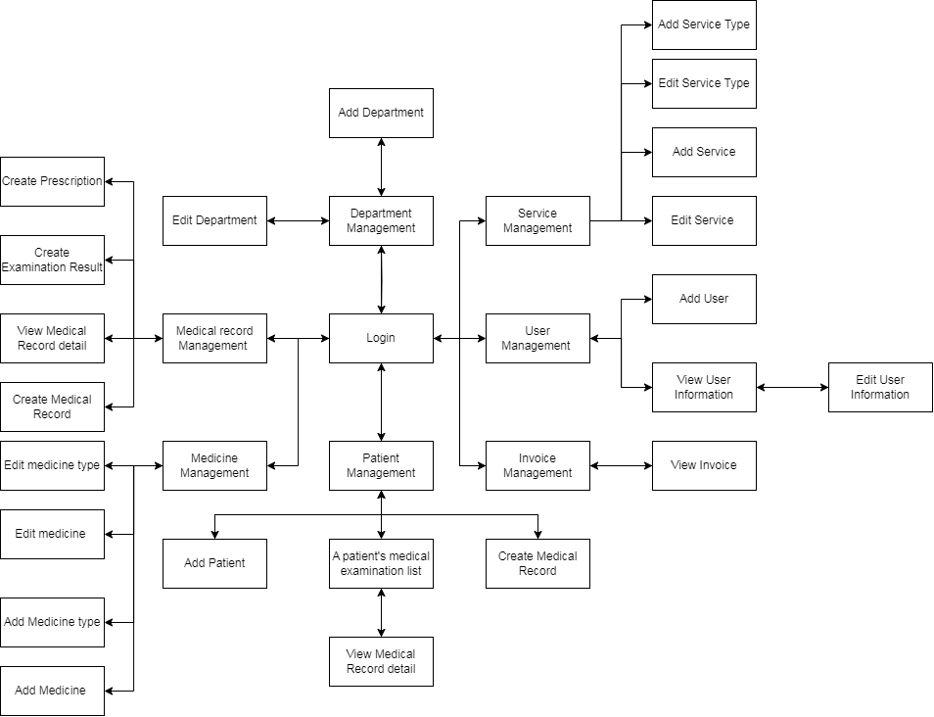

#### 3.1.2 Screen Descriptions

| **#** | **Feature** | **Screen** | **Description** |
| --- | --- | --- | --- |
| 1 | Access management | Login | Screen for logging in to an existing account. |
| 2 | User Management | User Management | Screen for viewing list user |
| 3 | User Management | Add user | Screen for add a user with one role |
| 4 | User Management | View user information | Screen for viewing a user’s profile |
| 5 | User Management | Edit user information | Screen for editting a user’s profile |
| 6 | Patient Management | Patient management | Screen for viewing list patient |
| 7 | Patient Management | Add Patient | Screen for add a new patient |
| 8 | Patient Management | A patient's medical examination list | Screen for view a patient's medical examination list |
| 9 | Patient Management | Create medical record | Screen for creating a medical record |
| 10 | Medical Record Managementt | View medical record detail | Screen for viewing a medical record detail |
| 11 | Medical Record Managementt | Medical examination management | Screen for viewing list of medical record |
| 12 | Medical Record Management | View medical record | Screen for viewing a patient’s medical record |
| 13 | Medical Record Management | Create examination result | Screen for creating a examination result after completing the examination |
| 14 | Medical Record Management | Create prescription | Screen for creating a prescription after completing the examination |
| 15 | Invoice Management | Invoice management | Screen for viewing list of patient |
| 16 | Invoice Management | View invoice | Screen for viewing a invoice detail |
| 17 | Service Management | Service management | Screen for viewing list of service type and list of service |
| 18 | Service Management | Add service type | Screen for adding a service type |
| 19 | Service Management | Edit service | Screen for editting a service type |
| 20 | Service Management | Add service | Screen for adding a service |
| 21 | Service Management | Edit service | Screen for editting a service |
| 22 | Medicine Management | Medicine Management | Screen for viewing list of medicine type and list of medicine |
| 23 | Medicine Management | Add medicine type | Screen for adding a medicine type |
| 24 | Medicin Management | Edit medicine type | Sceen for editting a medicine type |
| 25 | Medicine Management | Add medicine | Screen for adding a medicine |
| 26 | Medicine Management | Edit medicine type | Sceen for editting a medicine |
| 27 | Department Management | Department Management | Screen for viewing list of department |
| 28 | Department Management | Add department | Screen for adding a new department |
| 29 | Department Management | Edit department | Screen for editing a department |

#### 3.1.3 Screen Authorization

| **Screen** | **Manager** | **Cashier** | **Nurse** | **Doctor** |
| --- | --- | --- | --- | --- |
| Login | X | X | X | X |
| User Management | X |  |  |  |
| Add user | X |  |  |  |
| View user information | X |  |  |  |
| Edit user information | X |  |  |  |
| Patient management | X |  |  |  |
| Add Patient |  |  | X |  |
| A patient's medical examination list |  |  | X |  |
| Create medical record |  |  | X |  |
| View medical record detail | X |  | X | X |
| Medical examination management | X |  | X |  |
| View medical record | X |  | X | X |
| Create examination result |  |  |  | X |
| Create prescription |  |  |  | X |
| Invoice management | X | X |  |  |
| View invoice | X | X |  |  |
| Service management | X |  |  |  |
| Add service type | X |  |  |  |
| Edit service | X |  |  |  |
| Add service | X |  |  |  |
| Edit service | X |  |  |  |
| Medicine Management | X |  |  |  |
| Add medicine type | X |  |  |  |
| Edit medicine type | X |  |  |  |
| Add medicine | X |  |  |  |
| Edit medicine type | X |  |  |  |
| Department Management | X |  |  |  |
| Add department | X |  |  |  |
| Edit department | X |  |  |  |

#### 3.1.4 Entity Relationship Diagram

**Entities Description**

| **#** | **Entity** | **Description** |
| --- | --- | --- |
| 1 | Category | Represents different categories or types. |
| 2 | Contact | Stores contact information for individuals or organizations. |
| 3 | Employee | Information about employees within the organization. |
| 4 | ExaminationResult | Results of tests or examinations. |
| 5 | Invoices | Represents information about invoices. |
| 6 | InvoiceDetail | Details of items within an invoice. |
| 7 | MedicalRecord | Patient's medical record. |
| 8 | MedicalRecordDoctors | Link between medical records and information about doctors. |
| 9 | MedicalRecordCategories | Link between medical records and medical categories. |
| 10 | Patient | Information about patients. |
| 11 | Prescription | Details of prescriptions for patients. |
| 12 | Role | Represents various roles within the system. |
| 13 | Service | Services provided within the system context. |
| 14 | ServiceMedicalRecord | Link between services and a patient's medical record. |
| 15 | ServiceType | Type of service or service category. |
| 16 | Supplies | Information about items or materials supplied. |
| 17 | SuppliesPrescription | Link between prescriptions and items to be supplied. |
| 18 | SuppliesTypes | Types of items or materials. |
| 19 | User | User information within the system. |
| 20 | UserRole | Link between users and their roles. |

## 3. Non-Functional Requirements

### 3.1 External Interfaces

#### 3.1.1 Push-up notification Integration:

Notification Integration in External Interfaces involves the seamless incorporation of real-time alerts and notifications into external systems and applications. This integration enables the exchange of critical information between different platforms, ensuring that relevant parties are promptly informed about important events, updates, or changes.

#### 3.1.2 Integration with Monitoring and Alerting Tools:

The HCS software can integrate with monitoring and alerting tools, enabling automatic creation of tickets or incidents based on system or infrastructure alerts. This integration helps streamline incident management and ensures timely responses to critical incidents.

### 3.2 Quality Attributes

#### 3.2.1 Security:

Authentication and authorization: The software should provide secure user authentication and role-based access control.

Data protection: The system should ensure the confidentiality, integrity, and availability of sensitive data.

Audit trail: The software should maintain logs and records of user activities for auditing purposes.

#### 3.2.2 Usability:

User interface: The system should have an intuitive and user-friendly interface.

Accessibility: The software should be accessible to users with disabilities.

Multilingual support: The system should support multiple languages for international users.

## 4. Requirement Appendix

### 4.1 Business Rules

| **ID** | **Rule Definition** |
| --- | --- |
| BR-01 | Users must log in to access the system. |
| BR-02 | The system should support the logout function. |
| BR-03 | Administrators have the right to add new users and edit their information. |
| BR-04 | Only administrators have the right to manage departments and edit department information. |
| BR-05 | All users can view the list of departments. |
| BR-06 | A department can be disabled, making it unavailable in the system. |
| BR-07 | A doctor can be assigned to one or more departments. |
| BR-08 | A service type must be added before adding a specific service. |
| BR-09 | Services must belong to a service type. |
| BR-10 | Service types can be disabled, making them unavailable when adding new services. |
| BR-11 | New patient records can be created and assigned to a doctor. |
| BR-12 | Patient records can be linked to one or more payment invoices. |
| BR-13 | Invoices must be exported to a PDF file for patient communication. |
| BR-14 | Invoices must be confirmed as paid before considering them complete. |
| BR-15 | Medical records can be exported to a PDF file for patient or archival purposes. |
| BR-16 | There is a list of medical records indicating unpaid and paid statuses. |
| BR-17 | Examination results can be generated and linked to patient records. |
| BR-18 | Examination results can be exported to a PDF file for patient communication. |
| BR-19 | The system must support the management of medicines and medicine types. |
| BR-20 | Medicine types can be disabled, making them unavailable when adding new medicines. |
| BR-21 | Each service may be associated with one or more medicine types. |
| BR-22 | There is a list of medical records that have been examined and those that are pending examination. |
| BR-23 | Prescriptions can be generated from patient records. |
| BR-24 | A bill can only be generated from a patient record with a confirmed payment result |

### 4.2 Application Messages List

| **#** | **Message code** | **Message Type** | **Context** | **Content** |
| --- | --- | --- | --- | --- |
| 1 | MSG01 | Pop-up | Send request ticket to system successfully | *Send request ticket successfully* |
| 2 | MSG02 | Pop-up, with red text | Create user have duplicate email | *Email {email} is already taken* |
| 3 | MSG03 | Pop-up, with red text | User with email not found | *User with email {email} not found* |
| 4 | MSG09 | In line | Email or password is not correct when clicking sign-in | *Incorrect email or password. Please check again.* |
| 5 | MSG10 | Pop-up | Internal server error | *Some error occurs, please contact the system admin!* |